11.1.1] Sum of Digits of Number
ALGORITHM
Step 1: Start the program
Step 2: Input an integer number from the user
Step 3: Initialize a variable sum = 0
Step 4: Repeat the following steps while num > 0
Step 4.1: Find the last digit
→ digit = num % 10
Step 4.2: Add the digit to sum
→ sum = sum + digit
Step 4.3: Remove the last digit from number
→ num = num // 10
Step 5: Print the result
→ "Sum of digits: ", sum
Step 6: End the program
PYTHON CODE
num = int(input("Enter a number: "))
sum=0
while num>0:
n = num%10
sum = sum+n
num = num // 10

print("Sum of digits:", sum )
FLOWCHART
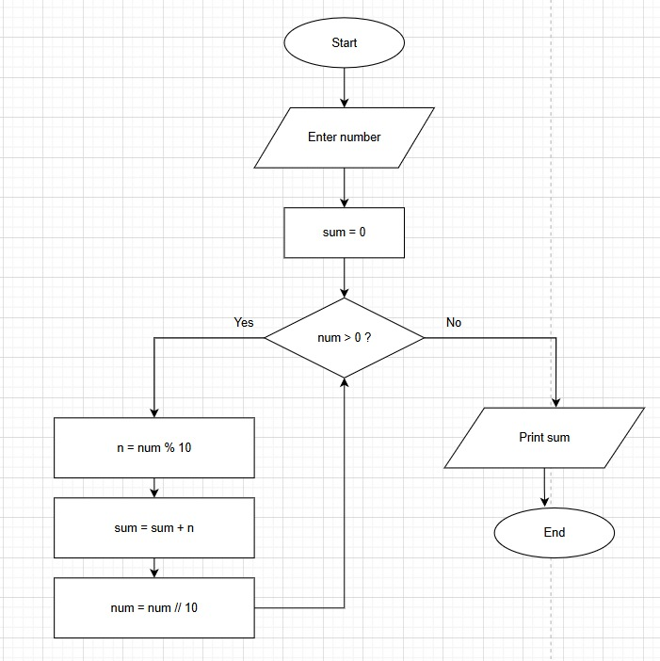EXCECUTION